1. Project Initiation, Requirement Analysis, Sitemap, Wireframe, and
GitHub Setup.
Wireframe:
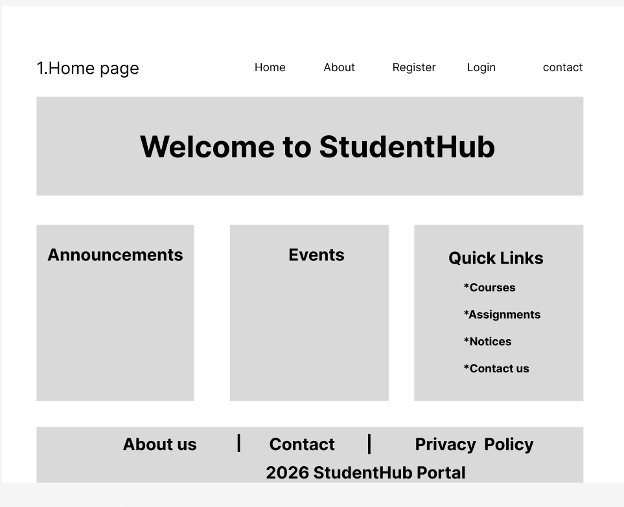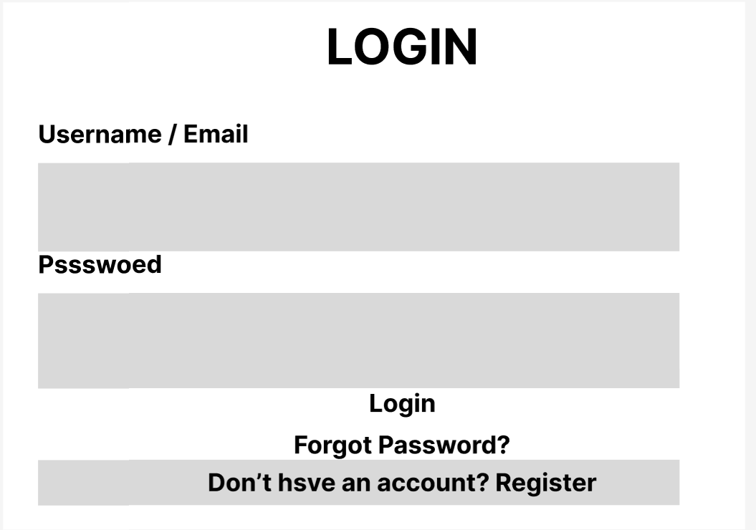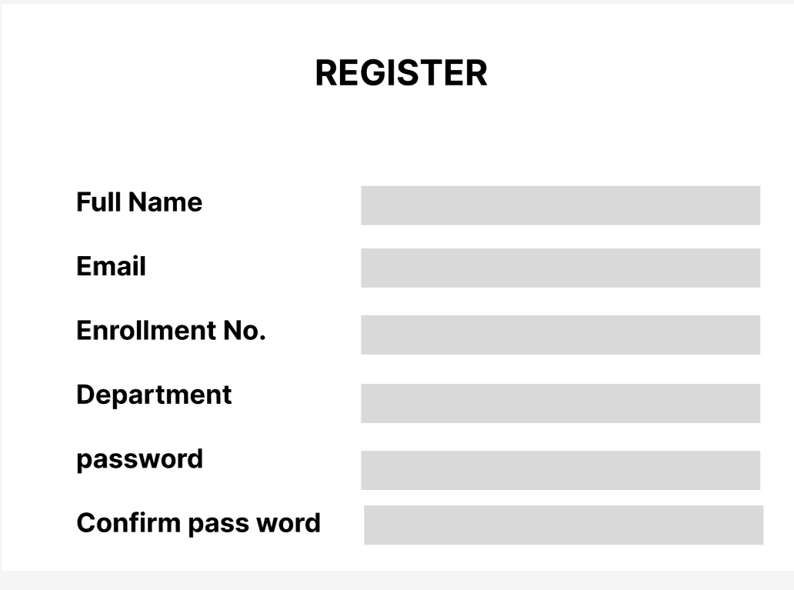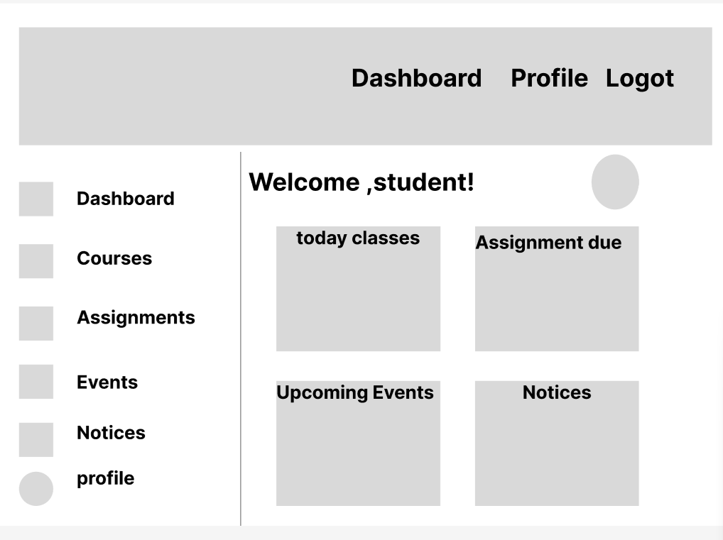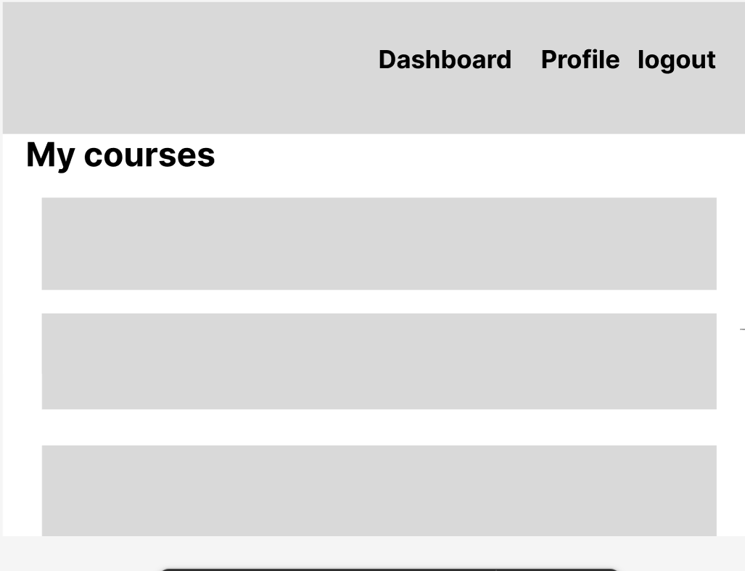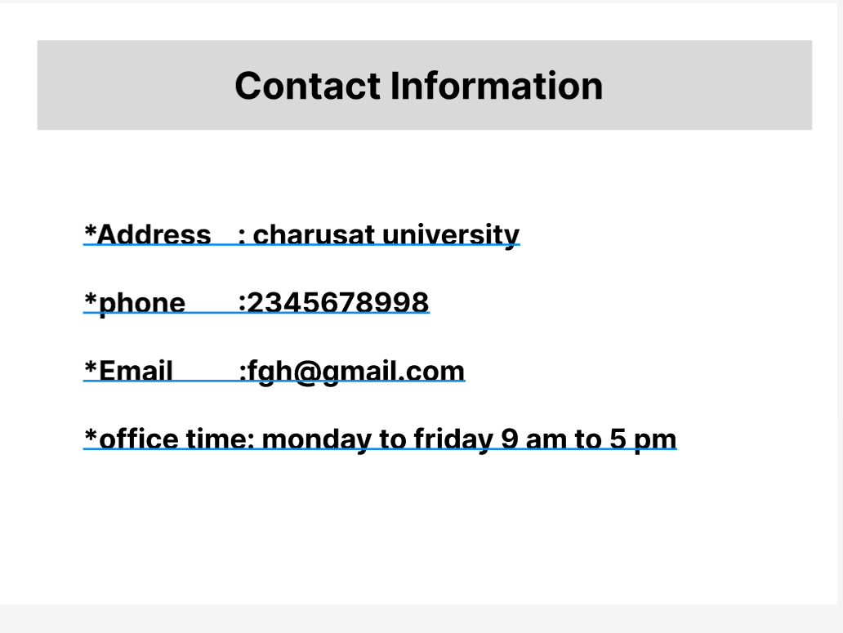
Sitemap:
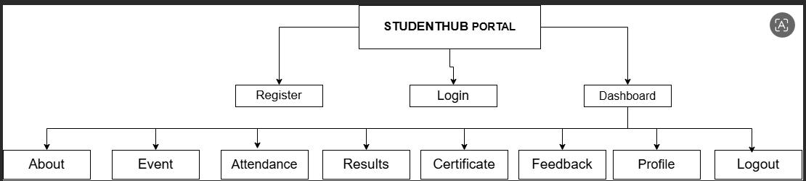

Requirement Analysis:
Requirement Analysis – StudentHub Portal
1. Project Title
StudentHub – Student Management Portal
2. Problem Statement
Students often need to access academic information such as attendance, assignments, results, notices, and timetables from different sources. Managing all this information separately can be confusing and time-consuming. StudentHub provides a centralized web portal where students can access all academic information from a single platform.
3. Objectives
- Provide a single platform for students.
- Manage academic records efficiently.
- Improve communication between students and faculty.
- Enable easy access to notices, assignments, and results.
- Maintain student profiles and attendance records.

4. User Roles
Student
- Register/Login
- View profile
- Check attendance
- View assignments
- View results
- View timetable
- Read notices
- Submit feedback
Admin
- Manage students
- Upload notices
- Manage attendance records
- Upload results
- Manage assignments
- Update timetable

5. Functional Requirements
Authentication Module
- Student Registration
- Student Login
- Logout
Profile Module
- View student details
- Update profile information
Attendance Module
- View attendance percentage
- View subject-wise attendance
Assignment Module
- View assignments
- Check submission deadlines
Result Module
- View semester results
- View subject-wise marks
Notice Module
- Display latest notices and announcements
Timetable Module
- View class timetable
Feedback Module
- Submit feedback or suggestions
Contact Module
- Contact administration

6. Non-Functional Requirements
- User-friendly interface
- Fast page loading
- Responsive design
- Easy navigation
- Secure login system
- Maintainable project structure

7. Minimum Pages
- Home
- Login
- Registration
- Dashboard
- Profile
- Attendance
- Assignments
- Results
- Notices
- Timetable
- Feedback
- Contact Us

8. Navigation Flow
Home
→ Login / Register
→ Dashboard
→ Profile
→ Attendance
→ Assignments
→ Results
→ Notices
→ Timetable
→ Feedback
→ Contact Us
→ Logout

9. Expected Output
A web-based StudentHub portal that allows students to access academic information through a structured and easy-to-use interface.

# StudentHub

## Project Overview
StudentHub is a web-based student management portal developed as a semester-long project. The portal provides students with a centralized platform to access academic information such as attendance, assignments, results, notices, timetables, and profile details.

## Objectives
- Provide a single platform for academic information.
- Improve communication between students and administration.
- Manage student records efficiently.
- Provide easy access to notices, assignments, and results.

## User Roles
### Student
- Register and Login
- View Profile
- Check Attendance
- View Assignments
- View Results
- View Timetable
- Read Notices
- Submit Feedback

### Admin
- Manage Student Records
- Upload Notices
- Manage Attendance
- Upload Results
- Manage Assignments
- Update Timetable

## Project Pages
1. Home (index.html)
2. Login (Login.html)
3. Registration (Register.html)
4. Dashboard (Dashboard.html)
5. Profile (Profile.html)
6. Admin (Admin.html)
7. Events (events.html)
8. FAQ (FAQ.html)
9. Feedback (Feedback.html)
10. Contact (Contact.html)
11. About (About.html)

## Project Structure
```
StudentHub/
│
├── index.html
├── About.html
├── Admin.html
├── Contact.html
├── Dashboard.html
├── FAQ.html
├── Feedback.html
├── Login.html
├── Profile.html
├── Register.html
├── events.html
│
├── docs/
│ ├── sitemap.png
│ ├── wireframes/
│
└── README.md
```

## Tools Used
- VS Code
- HTML5
- Draw.io (Sitemap)
- Figma (Wireframes)
- Git
- GitHub

## Practical 1 Deliverables
- Requirement Analysis
- Sitemap Design
- Wireframe Design
- Project Folder Structure
- GitHub Repository Setup
- README File

## GitHub Repository
StudentHub Project Repository

